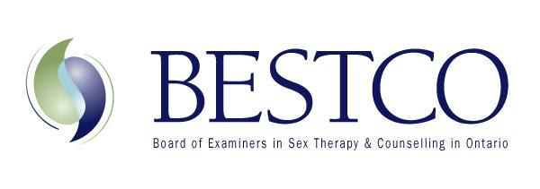
Michelle Fischler MSW, RSW, RP, Registrar me@michellefischler.ca

Dear Colleague,

We are so pleased that you are interested in joining BESTCO.

The completed associate application form must be emailed to the Registrar: me@michellefischler.ca

Once received by the Registrar your application will be reviewed by the Documentation Committee. This committee meets 4 times per year. You will be informed by the Registrar about when the next Documentation Committee meeting is scheduled. Once accepted as an associate member you will be informed via email by the Chair of the Documentation Committee. The Chair will welcome you and let you know of the steps required to attain full certified membership, including supervising requirements.

On your attainment of associate status, we will advise you of the date and the location of subsequent biannual BESTCO meetings and hope you will attend regularly. You will see these meetings advertised on our website under “Upcoming Events”. These meetings typically fall on Thursdays and Fridays. Thursday is the Education Module that we encourage all associates and certified members to attend. Non-BESTCO clinicians, educators and medical professionals in the community are also welcome, so if you haven’t heard back from us about your application status please join. The only portion of the meeting that is for associates, certified members and affiliates only is the business meeting and that generally happens on the Friday morning.

If you have questions at any point in this process, please do not hesitate to email me@michellefischler.ca

Thank you for your interest in BESTCO.

Sincerely,

Michelle Fischler MSW, RSW, RP
BESTCO Registrar

