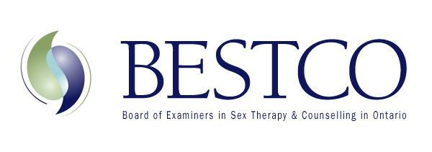
Registrar: Michelle Fischler MSW RSW, RP me@michellefischler.ca

APPLICATION CHECKLIST
Name:
Date of application:

Please ensure all documents below are attached in your Application to BESTCO. Applications will not be accepted and reviewed until all documents are received as a complete package.

- Application for associate membership

- Documentation of membership in good standing from your professional credentialing body
- Documentation of malpractice insurance coverage
- Two letters of recommendation (at least one from a recent or current clinical supervisor)

- Document completion of one full credit, graduate level intensive sexuality course*
  - Minimum of 35 hour course covering sexuality, sexual health and sex across the lifespan.

- Documentation of completion of a Sexual Attitudes Reassessment (SAR)*Minimum of 14 hours

- Completed Application Checklist
*If you do not have a SAR or graduate course in sexuality, you are still eligible to become an associate member. These two courses are required before full certification, which generally takes 3 years once you are an associate member.

*If you are uncertain if a sexuality course qualifies, please send the course outline to Registrar, Michelle Fischler at me@michellefischler.ca

When your full package is complete, please send all documents to Michelle Fischler at me@michellefischler.ca

Once your package is received by the Registrar you will be required to pay the application fee of $50.00 to Jennifer Ewen, Treasurer at treasurer@bestco.info

